Name: Jagtap Shivraj Vaibhav
Roll no: EN24107060
Class: SY- AI&DS – A
Subject : Robotics and Automation (MDM)
______________________________________________________________________________________________

Experiment No-5

Title: Simulation & Demonstration of Pick and Place Robotic System using RoboDK
Aim: To develop, simulate and demonstrate a simple material handling Pick and Place robotic system using RoboDK software
Theory :
Material handling robots are widely used in industries for automatic picking and placing of components. A Pick and Place robot uses programmed joint and linear movements to transfer objects from one location to another. RoboDK software provides offline programming and simulation environment for industrial robots, allowing users to create virtual robotic cells before real implementation.
Component Used:
- 1. 6-Axis Industrial Robot
- 2. Robot Controller (Virtual)
- 3. Worktable / Base Frame
- 4. Workpiece (Box/Cylinder)
- 5. Gripper (End Effector)
- 6. Reference Frames
- 7. Targets and Program Instructions
Procedure:
- 1. Open RoboDK and create a New Station.
- 2. Add a 6-axis industrial robot from the online library.
- 3. Insert a worktable and position the robot properly.
- 4. Import the workpiece and place it on the table.
- 5. Add a gripper and attach it to the robot flange (Define TCP).
- 6. Create Pick and Place reference frames.
- 7. Teach required targets: Home, Approach Pick, Pick, Lift, Approach Place, Place, Return Home.
- 8. Create a new program and insert MoveJ and MoveL commands.
- 9. Add Attach and Detach commands to simulate gripping.
- 10. Set speed, acceleration and enable collision detection.
- 11. Run simulation and verify smooth operation.
Program Logic:
- MoveJ Home
- MoveJ Approach Pick
- MoveL Pick
- Attach Object
- MoveL Lift
- MoveJ Approach Place
- MoveL Place
- Detach Object
- MoveJ Home
OPERATION FLOW SEQUENCE:
step | operation
1 | Robot moves to Home Position
2 | Robot approaches Pick Position
3 | Robot picks the object
4 | Robot lifts the object safely
5 | Robot moves to Place Position
6 | Robot places the object
7 | Robot returns to Home Position

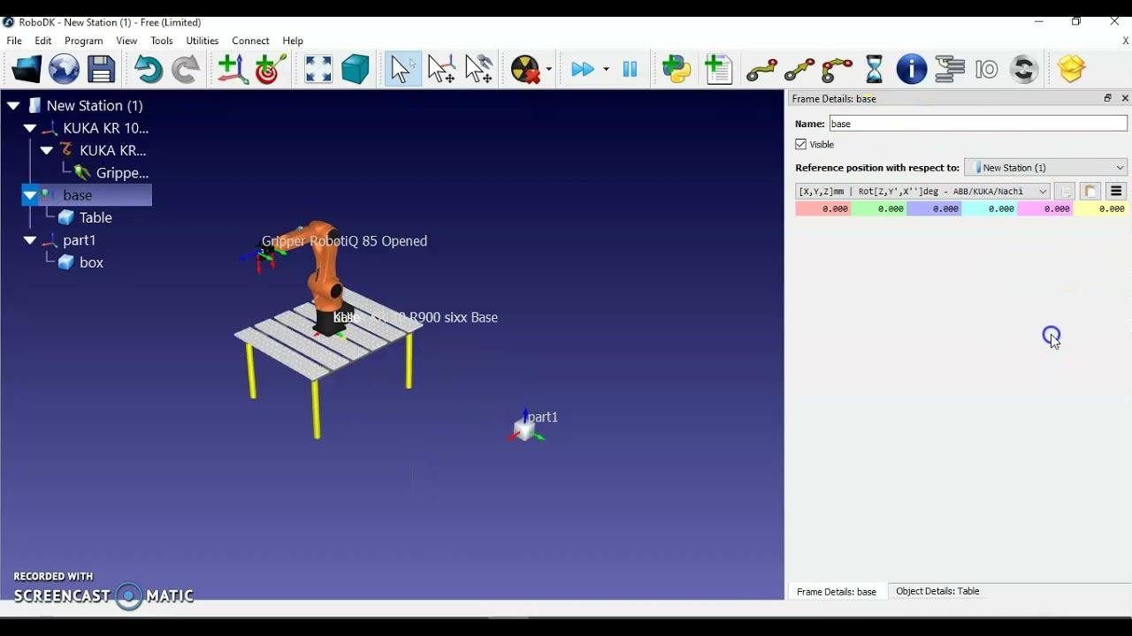
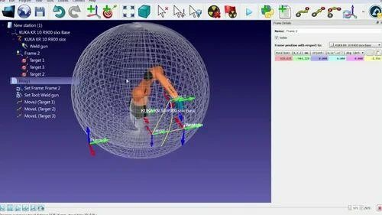

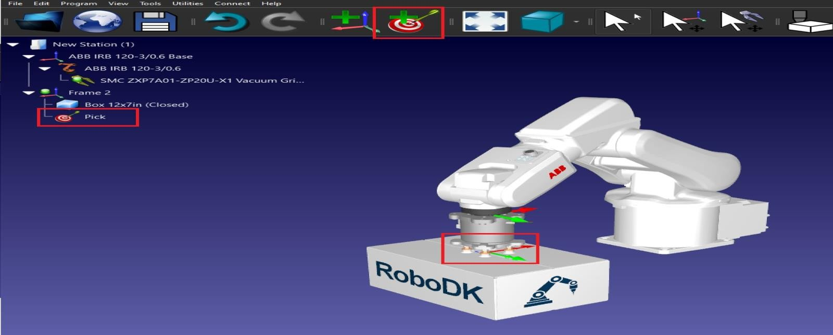

APPLICATIONS:
- Packaging and Sorting Systems
- Assembly Line Automation
- CNC Machine Loading and Unloading
- Pharmaceutical Material Handling
- Food Industry Automation
ADVANTAGES:
- Reduces manual labor
- Improves accuracy and repeatability
- Increases production rate
- Enhances safety in hazardous environments
RESULT: The Pick and Place robotic material handling system was successfully developed and simulated in RoboDK. The robot accurately picked the object from the source location and placed it at the destination location.
Conclusion:
- This experiment successfully demonstrated the development and simulation of a Pick and Place robotic system using RoboDK software. The study provided a clear understanding of material handling operations and the role of industrial robots in automation.
- By creating reference frames, defining targets, and programming motion sequences using MoveJ and MoveL commands, the robot was able to accurately pick and place objects between specified locations. The use of attach and detach functions effectively simulated the gripping mechanism, ensuring realistic operation.
- The experiment also highlighted the importance of proper path planning, speed control, and collision detection for smooth and safe robot operation.
- Overall, this experiment enhanced practical knowledge of robotic programming, simulation, and industrial applications, making it an essential step toward understanding real-world automation systems.

